Lesson 1 – Introduction to Kingdom Fungi Teacher Notes
Goals
The purpose of this lesson is to introduce high schools students to basic concepts about Fungi. Specifically the goals are:
- To help students understand what are fungi.
- To identify different fungal ecologies.
- To learn about fungal spores, and learn how to make a spore print.
- To understand what is a mushroom.
- To become aware of the diversity of fungal fruiting bodies.

Desired Prerequisites for Students
This lesson should be taught to advanced middle or high school students, who have background knowledge in cellular biology and concepts of Eukaryotes and organelles. No prior knowledge of fungi is necessary.

Materials
- Computer and projector.
- Access to the internet is needed to play the 3 relatively short videos which are on YouTube.
- Several mushrooms (the exact number will depend on the number of students). Try to get edible species either at the grocery store (where you could buy white or brown button mushrooms, Chanterelles, and shiitakes) or outside if you know which species are edible in your area.
- Butter knives or plastic knives to cut the stems off mushrooms. Students can share.
- Black and white spore print papers (see end of document to print your own), cut into ~4 or 5 inch squares (big enough for your mushrooms). You will need enough squares for each person (group) to make spore prints.
- Bowls or cups to cover mushroom caps once they are placed on the spore print paper. See Figure 1.

Slide Notes
- Today’s topic – Fungi. Ask students if they know what fungi are. Students may mention mushrooms, yeast, athlete’s foot, etc. Move forward by saying we will discuss many of these topics today.
- A. This is tree showing how all of life is related to one another. We call this type of tree a phylogeny. There are many types of organisms, and animals represent only one branch on this tree!! Show the circle representing Eukaryotes.
B. Click forward to reveal larger labels of Animals, Fungi, and Plants. Explain that Animals and Fungi are closely related compared to other types of living things, and much more closely related than either are to Plants.
- Explain that fungi are not plants. Remind students of photosynthesis. No fungi photosynthesize.
- Here we explain characteristics of Fungi. If you need to review the definition of Eukaryotic life, do so. If students ask, Chitin is a polymer of glucose that has a rigid structure. Plants have a cell wall with Cellulose, not Chitin. The following slides go further into some of these characteristics.
- Fungi are get their nutrition by living on or within other organisms or substrates, where they can obtain access to organic material. Go through examples. (Corn smut, Onygena, and Penicillium)
- This means that ecologically, fungi play many different roles, not just in decomposition. Go through these, and click to reveal which pictures depict the different ecological niches. Mycorrhizal fungi associate with the roots of plants in a symbiosis that benefits the plant by increasing root surface area and providing micronutrients (e.g. Phosphorus), and benefits the fungus by providing plant carbohydrates.
- Here, point out that a special group of fungi, called yeasts have different lifestyles, and exist mainly as unicellular cells.
- Another key fungal characteristic is the production of spores. Since fungi cannot easily move from one place to another, spores are an important mechanism in dispersal, and in finding new substrates or hosts to live on. There is great diversity in spore size and shape.
- Go through the slide. Ask students why people would want to make a spore print. Explain that spore color is important in identification of many mushroom species, and that it is not always easy to tell what color a mushroom’s spores will be just by looking at it. Ask why a piece of paper with both black and white sides would be used. Help students understand that darker spores can be more easily seen on the white paper, and lighter spores can be easier to see on the black. For example, it is almost impossible to tell the difference between purple and black spores on the black side. But cream colored spores can appear better on the black side.
- Have students follow directions. All materials should already be prepared beforehand. Make sure there is space to leave these undisturbed overnight. Don’t forget to check them tomorrow!
- As students are finishing spore prints, start the first video (5:00). This video is about one species’ amazing tactic to get their spores dispersed to the next habitat. This species is called Pilobolus, as the man explains.
Play the next video (1:54), which is several slow motion images of the same fungus firing its spore.
- Because animals and fungi are so closely related, they share many characteristics. Go over some of those here. Extra details are listed in the notes section below the slide and include: Morphological similarities: Mitochondrial structure (cristae are flattened), motile state (a single posterior facing flagellum). Insects and some other arthropods and crustaceans are the animals that produce chitin.
- Now that you have discussed similarities between fungi and animals, challenge students to think of differences. These could include: differences in motility, animals have a fixed body plan whereas fungi can change multiple times throughout their lives, differences in lifespan, complex organ systems developed in many animals, differences in size (fungi are really microbes for the most part if not all of their lifecyles). Etc.
- Transition here to mushrooms. Most students will be most familiar with mushrooms as the quintessential fungus. So what is a mushroom? Explain that some fungi make mushrooms to disperse their spores. This is the reproductive structure, which we call a fruiting body, where spores are produced and ejected from. In that sense, mushrooms are not the “whole” fungus, they are analogous to an apple on a tree. The apple is not the whole tree.
- So challenge students to think about the rest of the fungus that is probably still growing underground when they see a mushroom.
- Go over the parts of a mushroom, and explain the different spore bearing surfaces under the cap of a mushroom.
- Many fungi don’t make mushrooms to produce and eject their spores. Many make other types of fruiting bodies though.
- Truffles, puffballs, and earthstars. Go through these, then play the video (0:50) at the bottom of the page to see an example of a huge puffball!
- Talk to students about animal dispersal, in this case flies and other insects.
- Conks
- Explain that spores are shot out of the center of cup and flask shaped fungi. Each flask on the dead spider contains thousands of spores. This is a good lead in to Lesson 2 about Insect Pathogenic Fungi. The End.
- Photo credits.

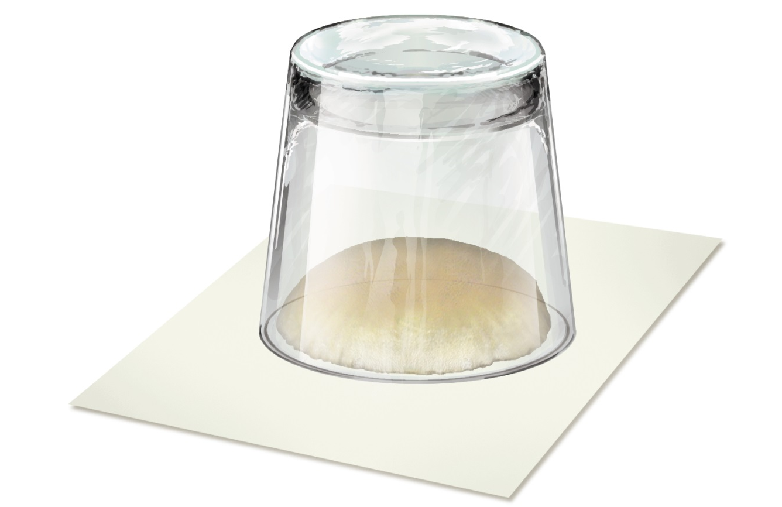Figure 1. Cup covering a mushroom cap to help create a spore print.

